Carbody Structure and Exterior

Introduction

Use

Purpose

Parts List

All figures are assigned to an individual page unless views are required to show a complete listing of equipment.

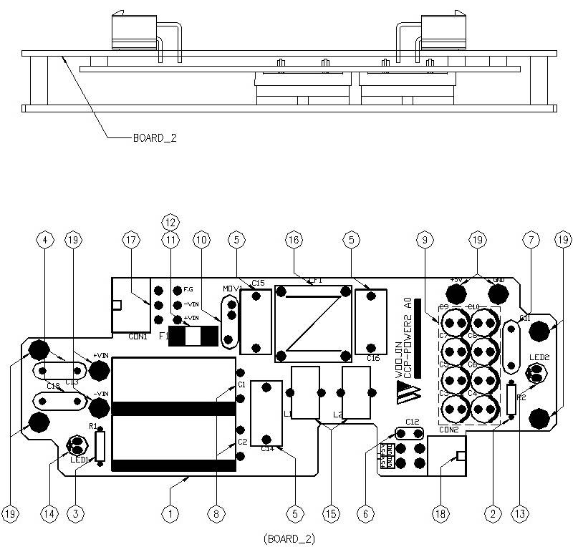

Figure 2.1. CCP Power Board2
Table 1 - Figure 2.1. CCP Power board2
FIG No. | PART NUMBERS |  |  | ITEM DESCRIPTION | VENDOR CODE | QTY
 | HRC | VENDOR | DTP
1 |  | CCP-POWER2 A0 |  | . BOARD | HANSAEM | 1
2 |  | MRS1/4W3KΩFTB  MGR251/4W3KΩFTP  SN1/4KT52R3KΩF |  | . CARBON FILM RESISTOR | ABCO  RARA  JEIL | 1
3 |  | MRS1/4W6.8KΩFTB  MGR251/4W6.8KΩFTP  SN1/4KT52R6.8KΩF |  | . CARBON FILM RESISTOR | ABCO  RARA  JEIL | 1
4 |  | SDE2E472  HCFZ2G472MAAP10 |  | . CERAMIC CAPACITOR | SAMWHA  NETRONTECH | 2
5 |  | PCX2-337-10224  MPX224K31D5 |  | . FILM CAPACITOR | PILKOR  CARLI | 3
6 |  | PCMT-365-85104  EB1J104K |  | . FILM CAPACITOR | PILKOR  SAMHWA | 1
7 |  | MPE630V222K |  | . FILM CAPACITORS | SUNGHO | 1
8 |  | KXL(NXB)63VB1000M7.5TP  RD1J108M16025PA |  | . ELECTROLYTIC CAPACITOR | SAMYOUNG  SAMWHA | 2
9 |  | LXZ35VB220M5.0TP  RD1V227M0811MPE |  | . ELECTROLYTIC CAPACITOR | SAMYOUNG  SAMWHA | 8
10 |  | INR14D151  SVC151D-14A |  | . VARISTOR | AMOTECH  SAMWHA | 1
11 |  | 0451010.MRL |  | . FUSE-SMD | LITTLE FUSE | 1
12 |  | 0154010.DRTL |  | . FUSE HOLDER | LITTLE FUSE | 1
13 |  | 5GG4SD-01, HIGH  SM5311, Y-GREEN |  | . LED | DAGUANG  AUK | 1
14 |  | 5R3SDA, HIGH  SR5311, RED |  | . LED | DAGUANG  AUK | 1
15 |  | 47uH/10A, Φ12, BLUE |  | . POWER INDUCTOR | TAESUNG  DAEKWANG | 2
16 |  | 2mH/3A, Φ12, RA |  | . LINE FILTER | TAESUNG  DAEKWANG | 1
17 |  | LAD1140-06P |  | . CONNECTOR | HANLIM | 1
18 |  | LAD1140-04P |  | . CONNECTOR | HANLIM | 1
19 |  | ROUND, M3XL6mm |  | . BOLT |  | 8

